readystatechange

The **readystatechange** event is fired when the [readyState](https://developer.mozilla.org/en-US/docs/Web/API/Document/readyState" \o "readyState) attribute of a document has changed.

This event is not cancelable and does not bubble.

[**Syntax**](https://developer.mozilla.org/en-US/docs/Web/API/Document/readystatechange_event#syntax)

Use the event name in methods like [addEventListener()](https://developer.mozilla.org/en-US/docs/Web/API/EventTarget/addEventListener" \o "addEventListener()), or set an event handler property.

JS

addEventListener("readystatechange", (event) => {});

onreadystatechange = (event) => {};

A generic [Event](https://developer.mozilla.org/en-US/docs/Web/API/Event).

**HTML**

HTML

<div class="controls">

<button id="reload" type="button">Reload</button>

</div>

<div class="event-log">

<label for="eventLog">Event log:</label>

<textarea

readonly

class="event-log-contents"

rows="8"

cols="30"

id="eventLog"></textarea>

</div>

**CSS**

**JavaScript**

JSP

const log = document.querySelector(".event-log-contents");

const reload = document.querySelector("#reload");

reload.addEventListener("click", () => {

log.textContent = "";

setTimeout(() => {

window.location.reload(true);

}, 200);

});

window.addEventListener("load", (event) => {

log.textContent = `${log.textContent}load\n`;

});

document.addEventListener("readystatechange", (event) => {

log.textContent = `${log.textContent}readystate: ${document.readyState}\n`;

});

document.addEventListener("DOMContentLoaded", (event) => {

log.textContent = `${log.textContent}DOMContentLoaded\n`;

});

Example

Bubbling

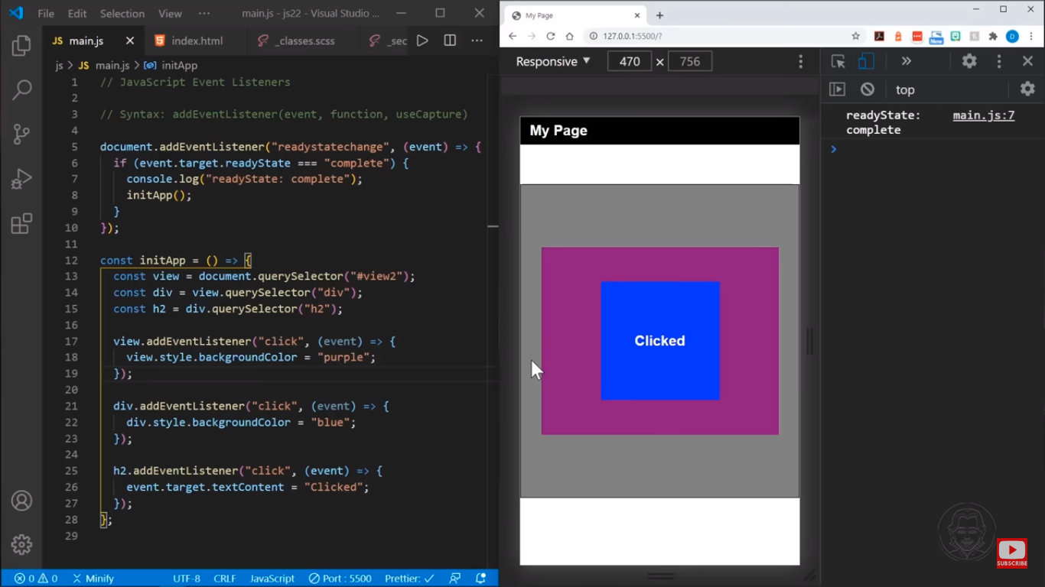

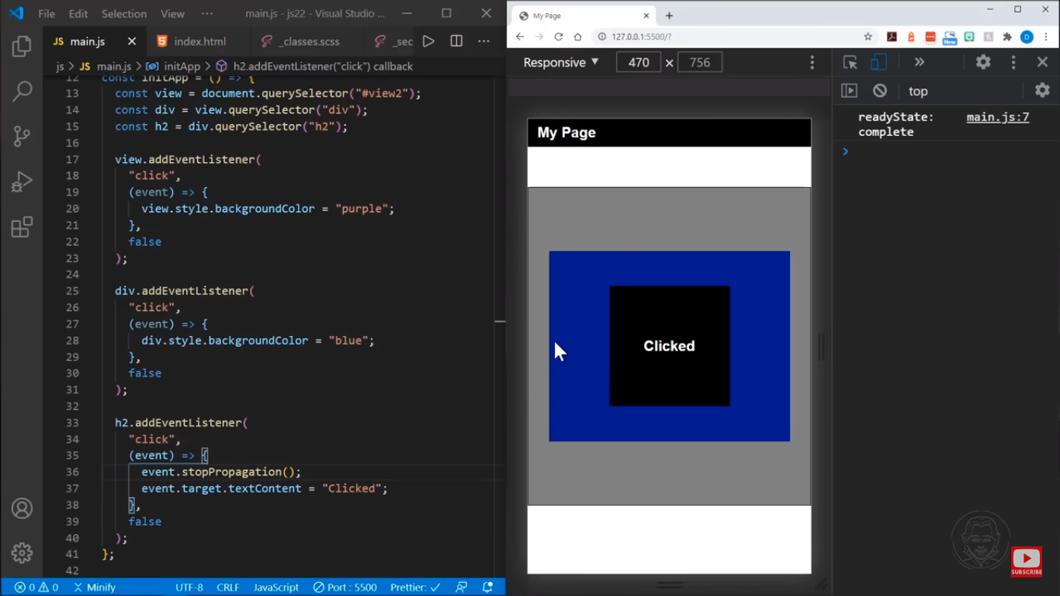

stopPropagation() is the method of event that stops elements to propagate inner element to outer element

Capturing

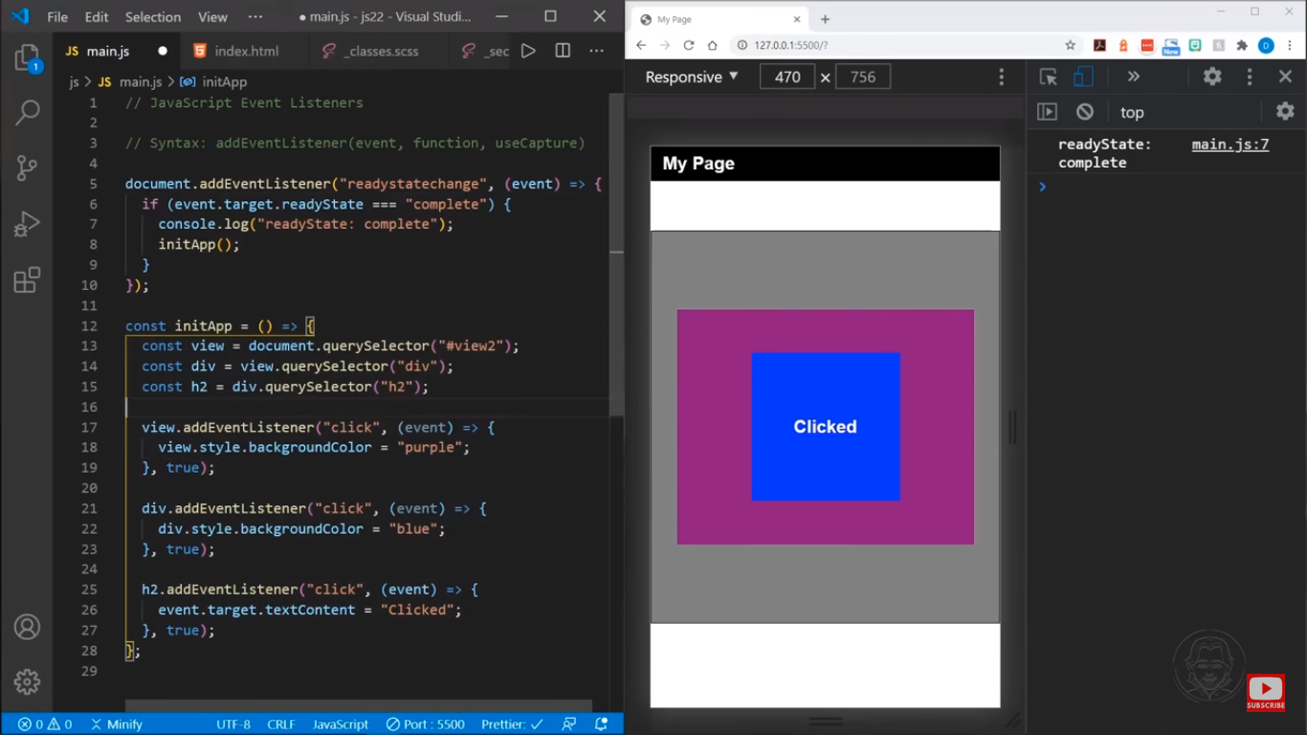

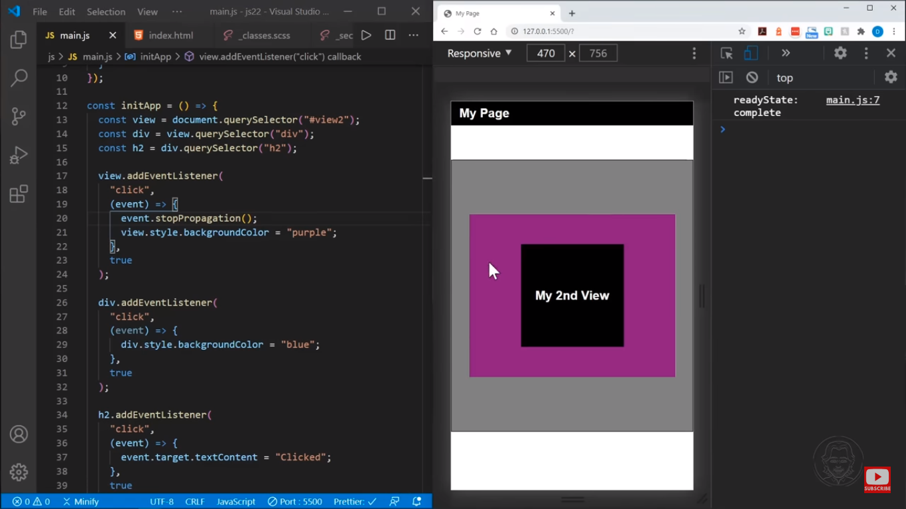

stopPropagation() is the method of event that stops elements to propagate outer element to inner element

* propagate meaning - spread and promote (an idea, theory, etc.)